Google net;

[Deep Learning: GoogLeNet Explained | by Richmond Alake | Towards Data Science](https://towardsdatascience.com/deep-learning-googlenet-explained-de8861c82765)

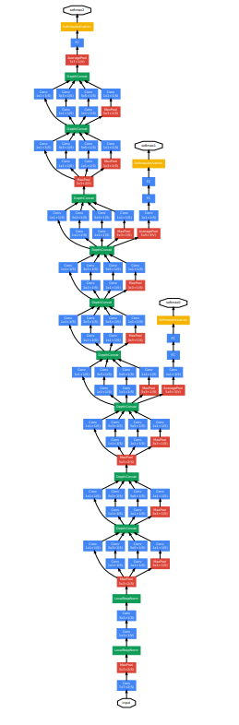

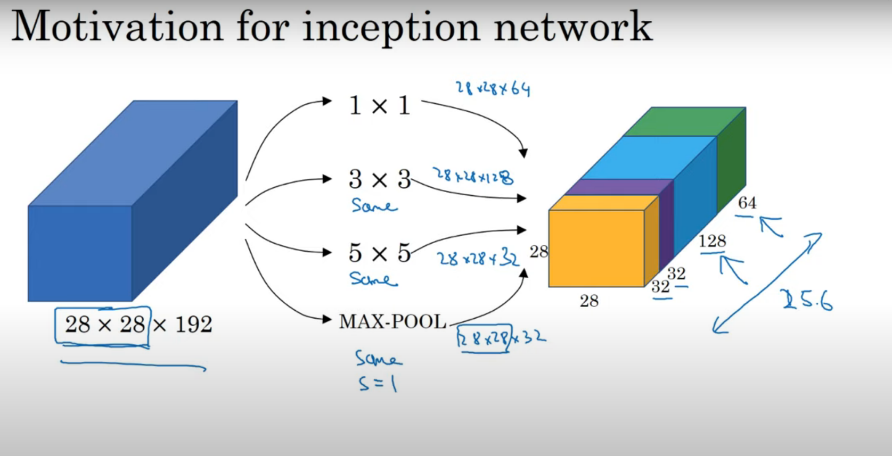

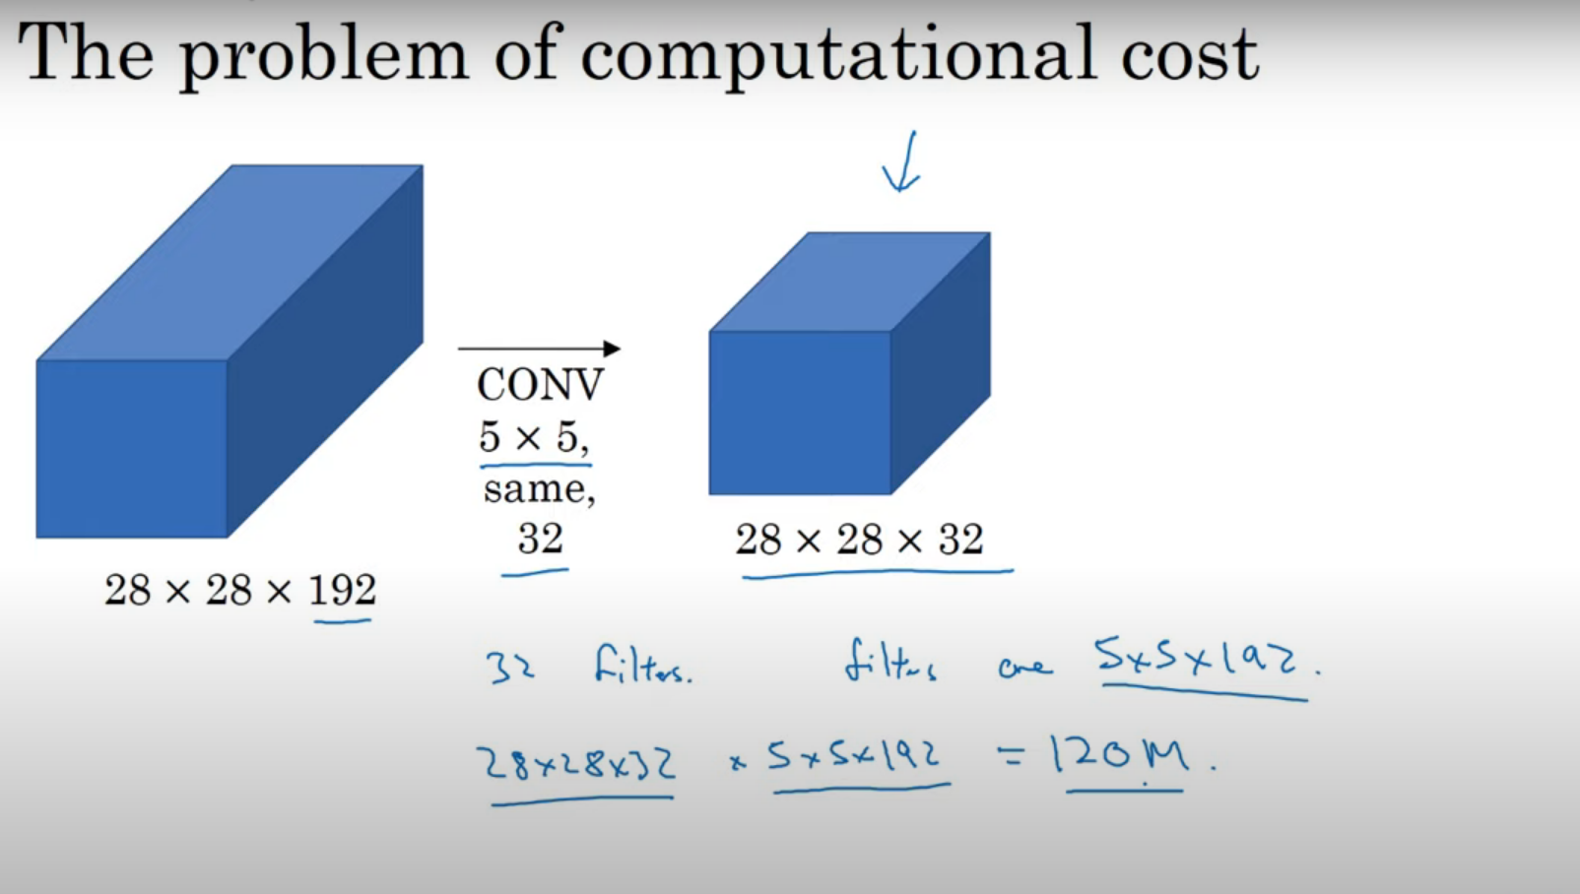

**Bottle Neck layer**

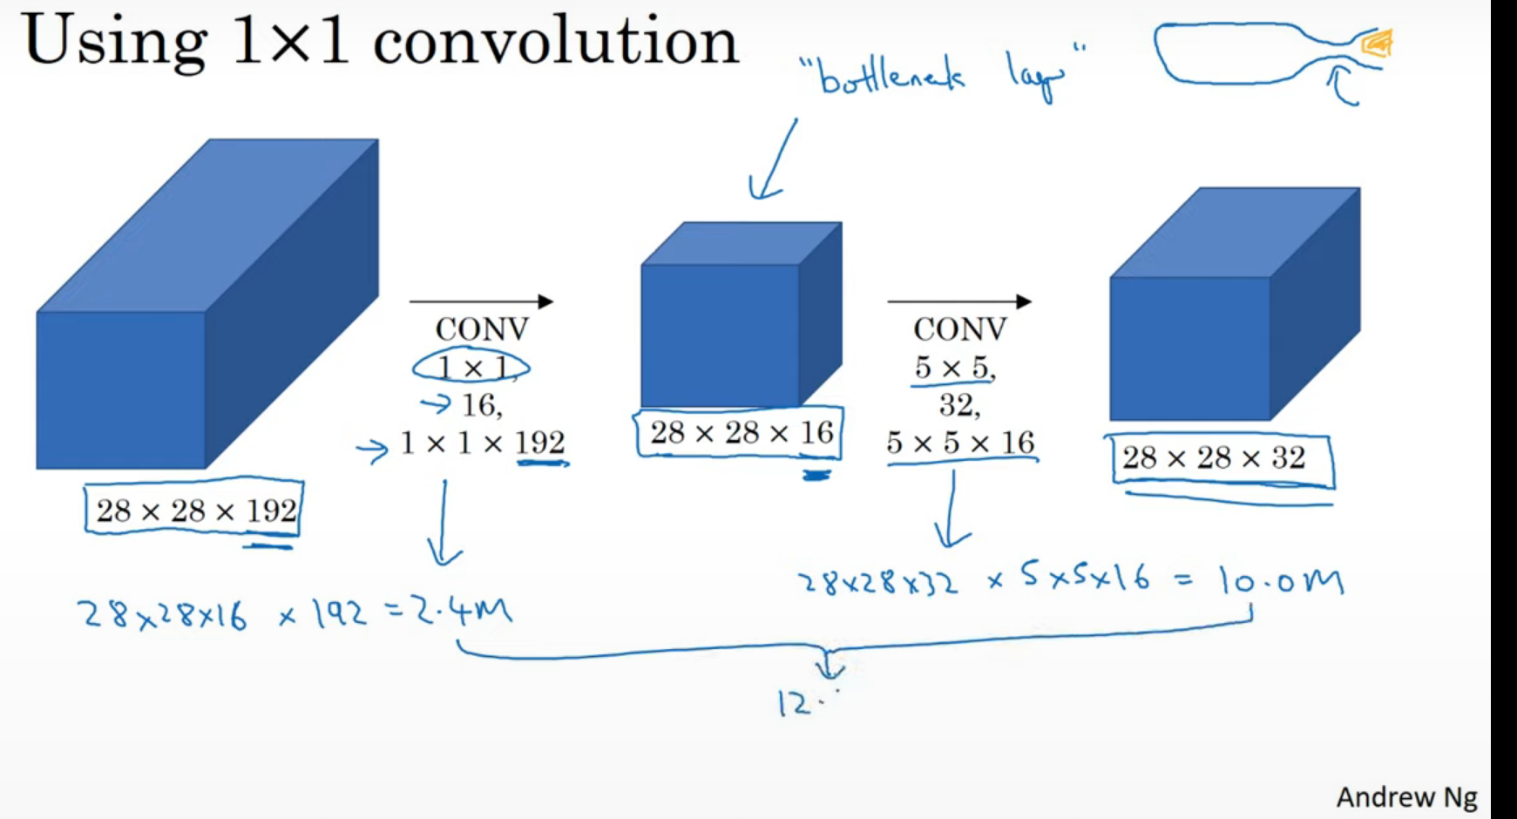

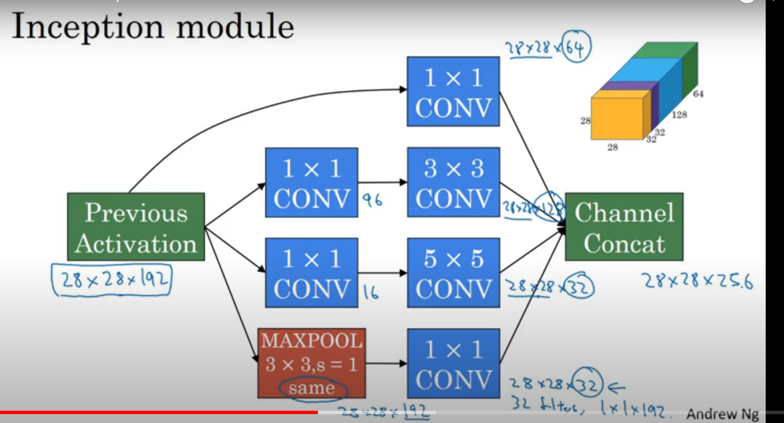

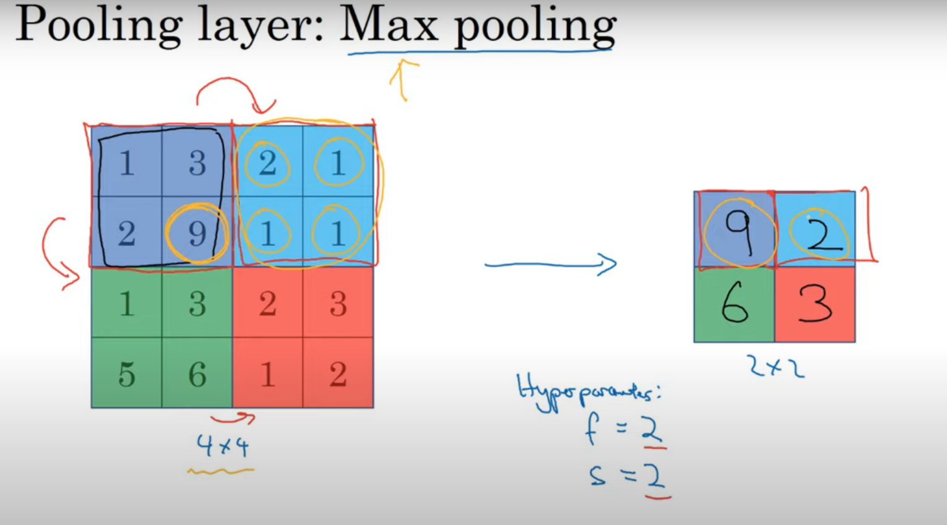

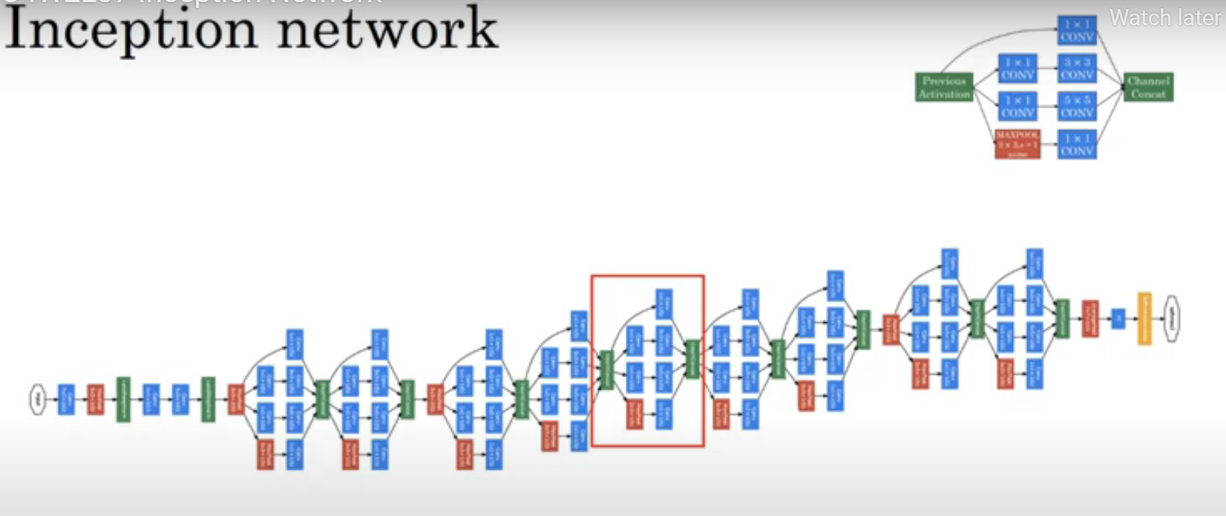

ResNet 50:

Ver very deep networks there is problem of Vanishing gradinent

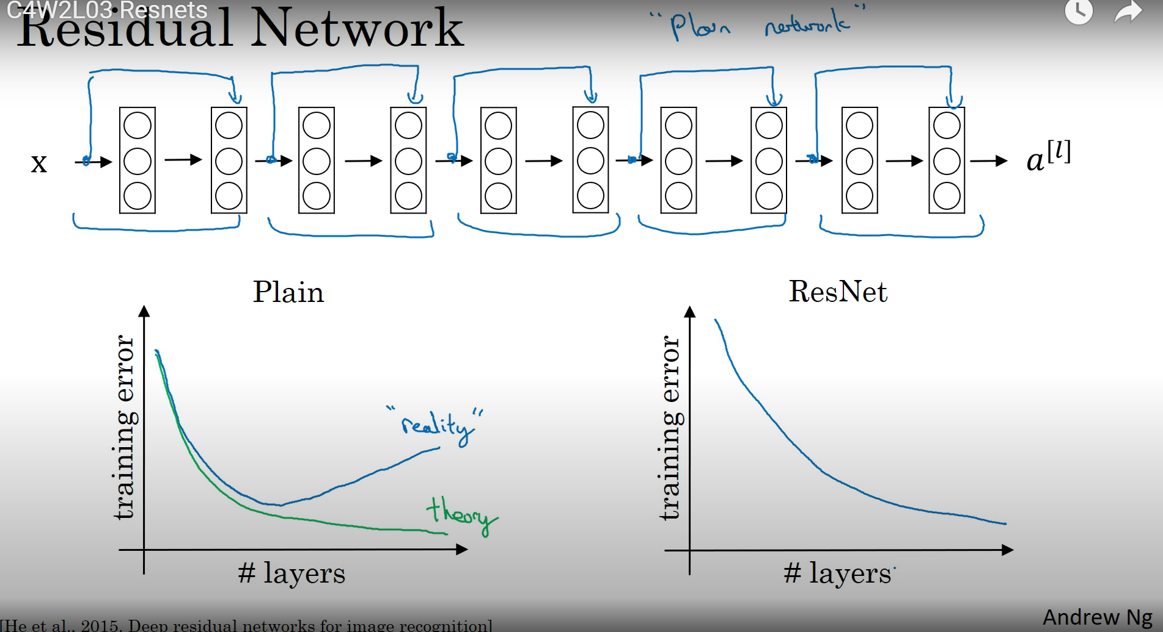

Residual block:

[Understanding ResNet50 architecture (opengenus.org)](https://iq.opengenus.org/resnet50-architecture/)

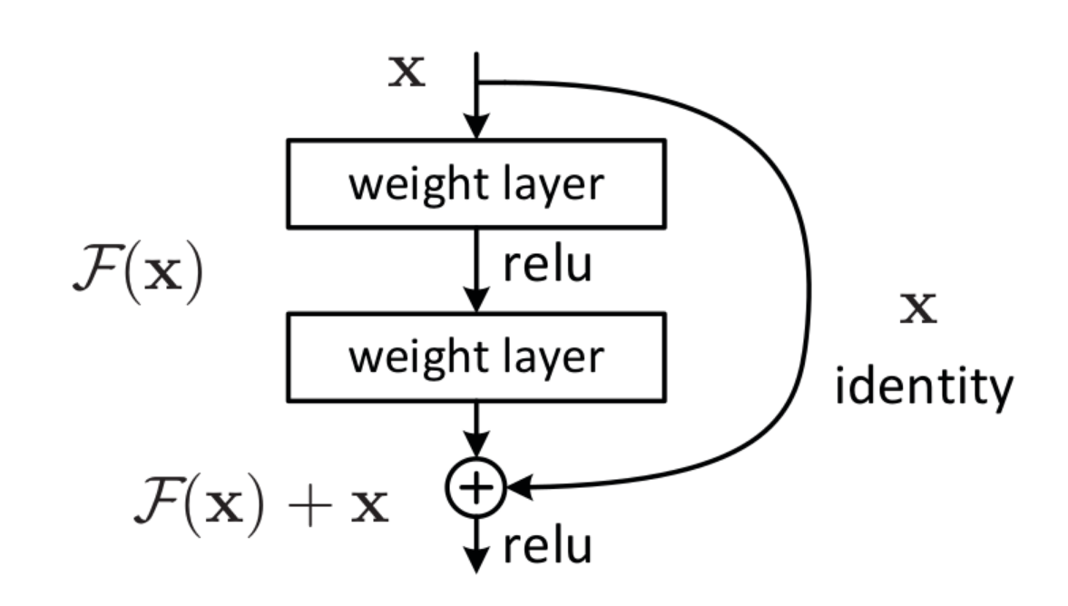

Insecption -ResNet V1

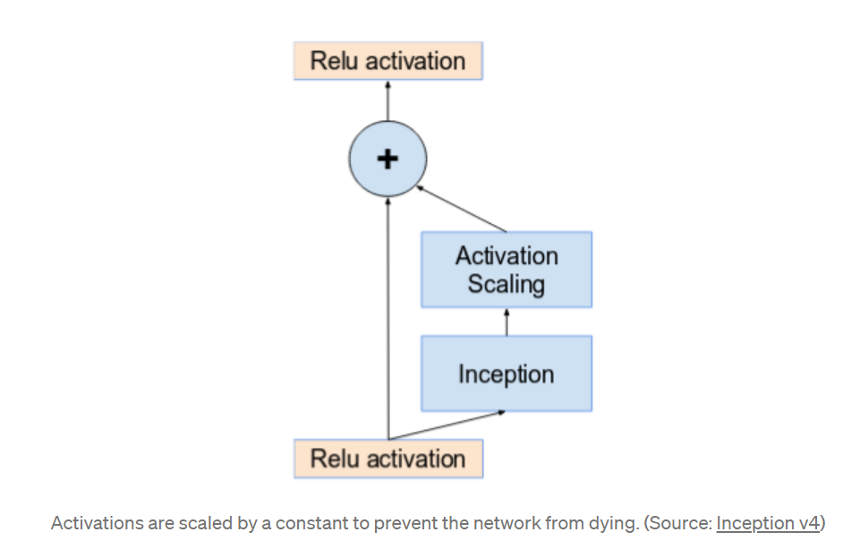

Proposal for train models

learning rate was set to 0.0001, validation frequency was set to 5, max epochs was set to 8, and the min batch size was set to 64.

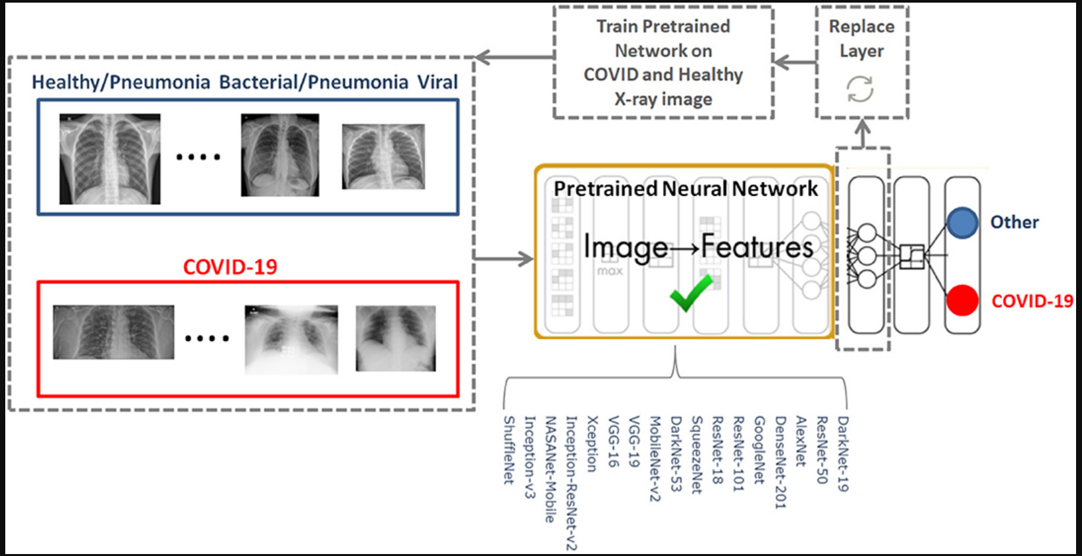

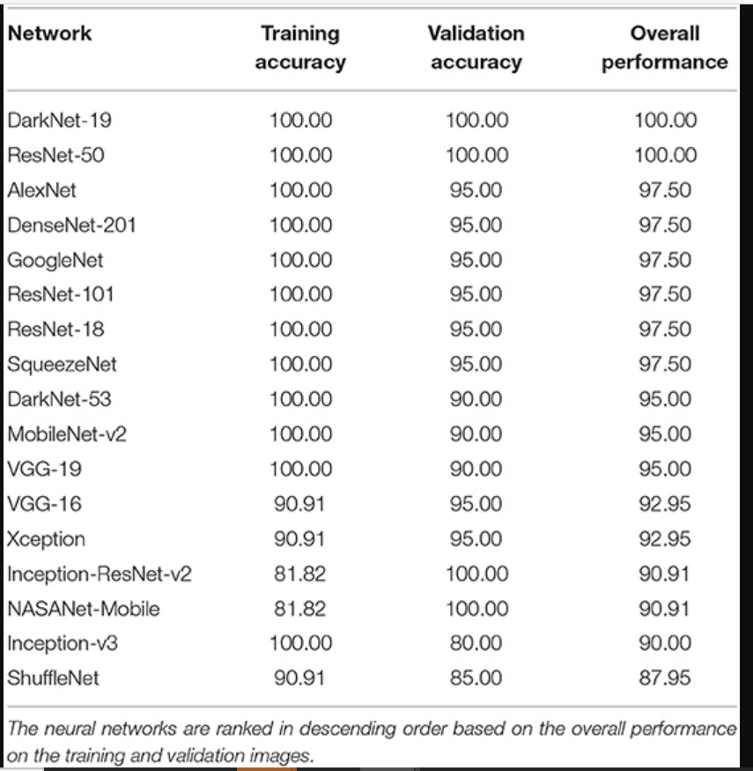

Inseption

[C4W2L06 Inception Network Motivation - YouTube](https://www.youtube.com/watch?v=C86ZXvgpejM&t=255s)

[A Simple Guide to the Versions of the Inception Network | by Bharath Raj | Towards Data Science](https://towardsdatascience.com/a-simple-guide-to-the-versions-of-the-inception-network-7fc52b863202)

Source: [C4W1L09 Pooling Layers - YouTube](https://www.youtube.com/watch?v=8oOgPUO-TBY)

Source: [C4W2L06 Inception Network Motivation - YouTube](https://www.youtube.com/watch?v=C86ZXvgpejM&t=255s)

Inception Net module:

Source: [C4W2L07 Inception Network - YouTube](https://www.youtube.com/watch?v=KfV8CJh7hE0&t=223s)

ResNet50:

Source:[C4W2L03 Resnets - YouTube](https://www.youtube.com/watch?v=ZILIbUvp5lk)

Source:2

[Frontiers | The Performance of Deep Neural Networks in Differentiating Chest X-Rays of COVID-19 Patients From Other Bacterial and Viral Pneumonias | Medicine (frontiersin.org)](https://www.frontiersin.org/articles/10.3389/fmed.2020.00550/full)

[2005.01468.pdf (arxiv.org)](https://arxiv.org/pdf/2005.01468.pdf)